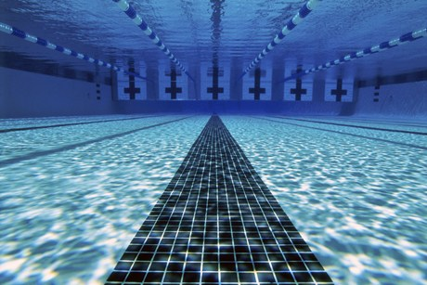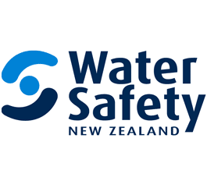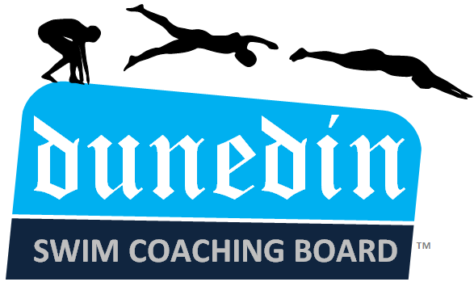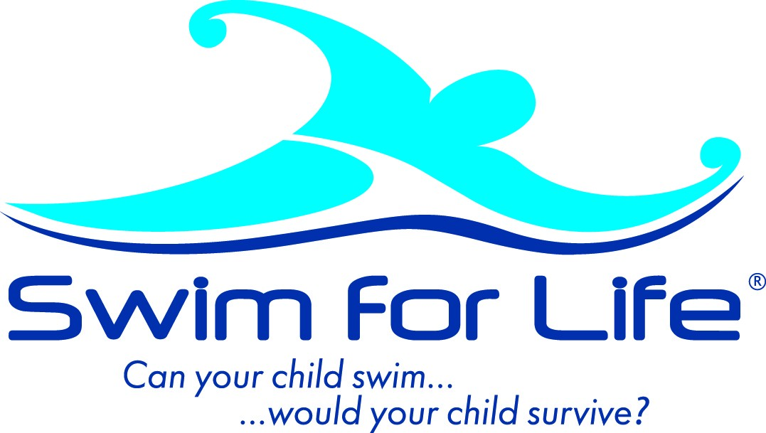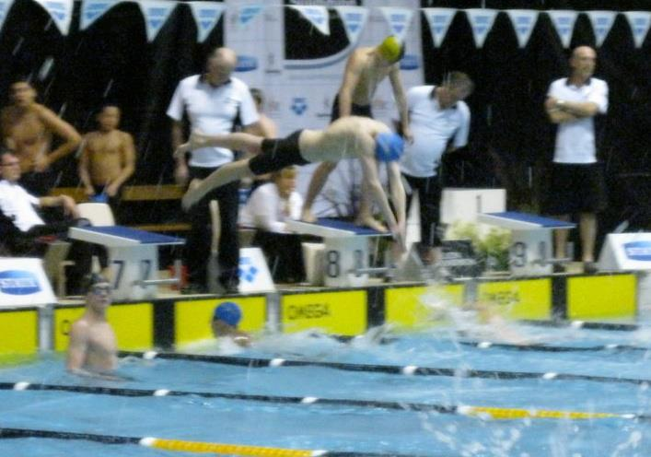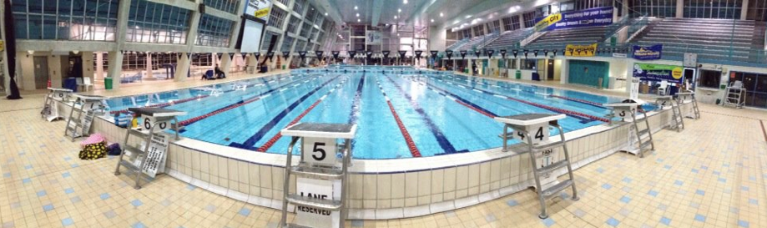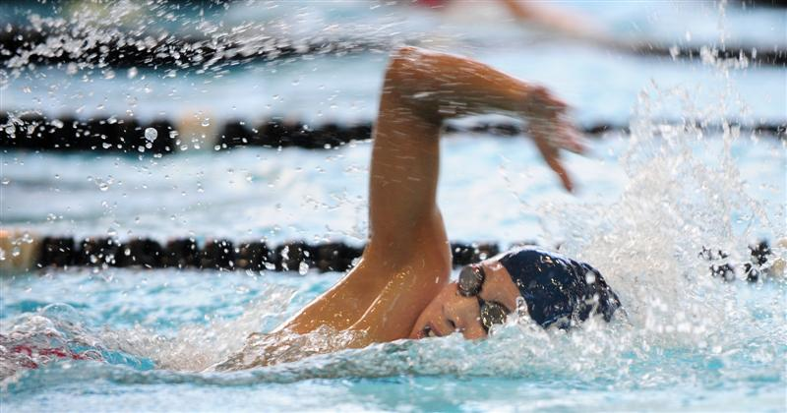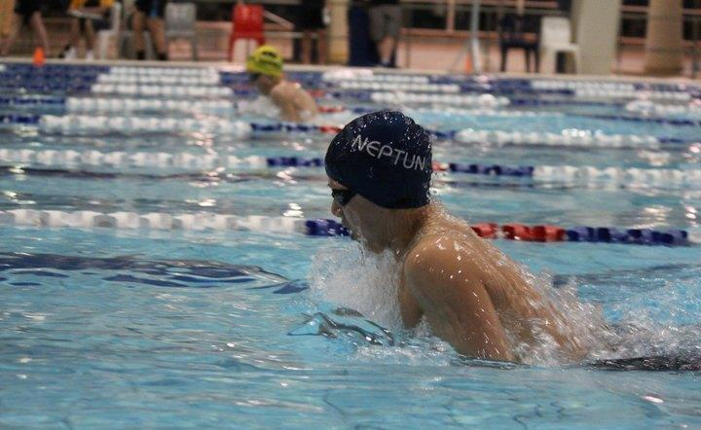

A 24-hour Swimming Relay. The rules are that at least one swimmer must be swimming in the pool at all times. Each member will be swimming for 2 hours until the team reaches the 24-hour mark. Each student will be swimming 8 hours all up. You will be able to donate on site or via the donation website:

<http://www.givealittle.co.nz/cause/the24hourswim>

Participants: Ben Simmers, Han Zhang, Ronald Poon

Location: Moana Pool

Time: 10am-10am

Date: 3rd-4th August

On average 105 New Zealanders die every year due to drowning. Drowning is the third highest cause of unintentional deaths in New Zealand. **New Zealand’s annual drowning toll is one of the worst in the developed world. Water Safety NZ goal is for** everyone in New Zealand to have the water safe skills and behaviors necessary to use and enjoy the water safely.

<http://www.watersafety.org.nz/>

### Water Safety NZ

Mcglashan Challenge 2013  
http://www.facebook.com/McglashanChallenge2013

McGlashan Challenge 2013

Like us on Facebook

## The Challenge

## The Cause

Information booklet

Swimming is a very large part of our lives and has helped to shape who we are today. None of us can imagine life without swimming. Sadly, for thousands of New Zealanders not only are they not able to enjoy the water, their lack of tom water safety skills causes them to be in danger in and around the water. Seven out of ten kiwi kids are not able to swim to save their lives. We think that this is completely unacceptable, and believe that every kiwi should have the ability to have fun in and around the water. That is why for our McGlashan challenge we have decided to support Water Safety New Zealand and their goal of having every New Zealander being able to swim.

*Han Zhang, Ben Simmers, Ronald Poon*

Sponsors

Like us on Facebook

Mcglashan Challenge 2013  
http://www.facebook.com/McglashanChallenge2013

## The Reason

Information booklet