**Swim Equipment**

Recommended Swim Equipment (Gear)

**Club Plus and Competitive Start Squads**

**Kickboard**

Smaller is best. A4 size.

Recommend: Ultralon kickboard (small) or Vorgee medium purple

**Pull buoy (small)**

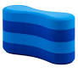 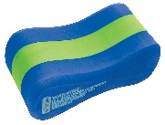

Recommend: Vorgee Pull Buoy 4 Layer **or** TYR Pull Buoy

**Finger paddles**

Recommend: Vorgee Finger Paddles

**Snorkel**

Recommend:Swimgear

**Fins (short)**

 Recommend:   [Zoggs (Blue Silicone) Short Fins](https://www.swimt3.co.nz/ultra-blue-short-blade-fin-zoggs.html)  [Arena (Powerfin Pro)](https://www.swimt3.co.nz/swimming/swim-accessories/fins/powerfin-pro-black-arena.html)

**Gear Bag (any)**

Recommend   [Speedo Mesh Gear Bag](https://www.swimt3.co.nz/swimming/swim-accessories/mesh-swim-bags/equipment-mesh-bag-speedo.html)    [Zoggs Mesh Gear Bag](https://www.swimt3.co.nz/swimming/swim-accessories/mesh-swim-bags/zoggs-aqua-sports-carry-all-mesh-assorted.html)

**Competitive Development, Competitive & Performance Squads**

**Kickboard**

Smaller is best. A4 size.

Recommend: Ultralon kickboard (small) or Vorgee medium purple

**Pull buoy (small)**

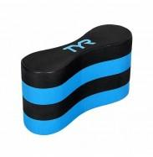 Speedo - Elite Pull Buoy - Black/Silver

Recommend: TYR Pull Buoy **OR** Speedo Elite Pull buoy

**Finger paddles**

Recommend: Vorgee Finger Paddles

**Snorkel**

Recommend: Michael Phelps or TYR Ultralite

**Fins (short)**

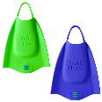

 Recommend:   [DMC Elite 2](https://www.swimt3.co.nz/ultra-blue-short-blade-fin-zoggs.html)  [Arena (Powerfin Pro)](https://www.swimt3.co.nz/swimming/swim-accessories/fins/powerfin-pro-black-arena.html)

**Hand paddles**

**OR** 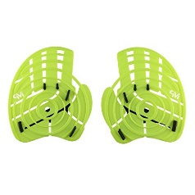

Recommend: Catalyst Stroke Paddle TYR Michael Phelp Strenth paddles

**Gear Bag (any)**

Recommend   [Speedo Mesh Gear Bag](https://www.swimt3.co.nz/swimming/swim-accessories/mesh-swim-bags/equipment-mesh-bag-speedo.html)    [Zoggs Mesh Gear Bag](https://www.swimt3.co.nz/swimming/swim-accessories/mesh-swim-bags/zoggs-aqua-sports-carry-all-mesh-assorted.html)